.
Application for patent filing

Date | D | D | M | M | Y | Y | Y | Y
 | 0 | 5 | 0 | 5 | 2 | 0 | 2 | 6

Name of the Faculty | : | Dr. R.Babu
Department | : | Department of Computational Intelligence
Faculty ID Number | : | 102893
Official E-mail ID | : | babur@srmist.edu.in
Personal E-mail ID | : | babu.rajen17@gmail.com
Contact number: |  | 7010691102
Major area of invention | : | Assistive technology and real-time sign language translation using IoT-enabled edge–cloud computing. The invention primarily focuses on improving communication accessibility for speech- and hearing-impaired individuals through gesture-to-speech conversion.
Narrow focus area of invention | : | A Raspberry Pi-based static hand gesture recognition system that uses MediaPipe landmark extraction, Random Forest classification, AI-driven sentence generation, and text-to-speech synthesis for portable daily communication
Title of the invention |  | EdgeSign: An IoT-Enabled Edge–Cloud Hybrid System for Real-Time Sign Language Translation
Earlier status of research | : | Previous systems mainly relied on sensor gloves or computationally expensive camera-based models that were either uncomfortable, costly, or unsuitable for embedded deployment. Most existing solutions focused only on isolated gesture recognition without contextual sentence formation.
How different your invention from similar research / others - Novelty? | : | EdgeSign introduces a low-cost edge–cloud hybrid architecture that processes hand landmarks instead of raw video for privacy and bandwidth efficiency, while also generating meaningful AI-based sentences rather than translating only individual gestures. This combination of portability, sentence-level intelligence, and real-time embedded deployment makes it distinct.
Possible domain for field application | : | Healthcare, education, assistive communication, social interaction, rehabilitation centers, and public service environments where inclusive communication is essential.
Possible sector for commercialization | : | Assistive healthcare devices, educational technology, smart accessibility solutions, IoT communication products, and wearable/mobile accessibility platforms for consumers and institutions.

PATENT APPLICATION
Invention Disclosure Form
To be filled by the inventors
Please provide highly relevant information for details asked below and use consistent language while describing the specific feature or element in the invention disclosure.
1. | Title of invention EdgeSign: An IoT-Enabled Edge–Cloud Hybrid System for Real-Time Sign Language Translation and Assistive Communication
2. | Describe the invention.  EdgeSign is a hybrid assistive communication system combining hardware, software, embedded computing, and AI. It is a portable Raspberry Pi-based device integrated with a Pi Camera, MediaPipe hand tracking, machine learning-based gesture classification, AI-driven sentence generation, and text-to-speech synthesis. The invention functions as a real-time sign language translation system that converts static hand gestures into meaningful spoken and textual communication through an edge–cloud architecture  Individuals with speech and hearing impairments often face communication barriers when interacting with people unfamiliar with sign language. Existing communication methods are often slow, dependent on interpreters, or inaccessible in daily environments. .  EdgeSign uses low-cost Raspberry Pi hardware with MediaPipe landmark extraction to avoid wearable sensors. It transmits only hand landmark coordinates instead of raw video, reducing bandwidth and preserving privacy. AI-driven sentence generation converts gesture sequences into grammatically coherent communication, making it more expressive than isolated word systems.
3. | Does the invention provide a new use of or improvement to an existing product or process? Yes. EdgeSign improves vision-based sign recognition by combining lightweight embedded hardware, edge–cloud collaboration, privacy-preserving landmark-only transmission, and sentence-level AI processing. Unlike prior work such as MediaPipe Hands (Google Research, 2020) or standard vision classifiers, this system transforms static gesture recognition into practical real-world assistive communication.
4. | State the Novelty of the invention and specify the claims in the invention  Novelty:  - Edge–cloud hybrid architecture for sign language translation  - Landmark-only data transmission for privacy and bandwidth optimization  - AI-driven sentence generation from gesture sequences  - Low-cost portable deployment using Raspberry Pi  Claims:  - A portable assistive communication system using Raspberry Pi and MediaPipe.  - A privacy-preserving gesture recognition framework transmitting structured landmarks instead of video.  - An AI sentence-construction module for contextual communication.  - A multimodal output system combining display and speech.
5. | Describe the advantages of the present invention over the existing technologies Advantages over existing technologies:  - Low cost  - Portable and battery-operable  - Real-time low latency  - Reduced network load  - Enhanced privacy  - Context-aware sentence generation  - User-friendly physical controls  - Scalable for future upgrades
6. | Describe in detail (with experimental evidences) on how the present invention overcomes the drawbacks of currently available technology related to your invention.  Experimental evaluation achieved 98% classification accuracy on gesture labels such as “call,” “eat,” and “go,” with millisecond-level recognition latency. Random Forest with shape-focused landmark features outperformed heavier deep-learning alternatives for embedded deployment by maintaining accuracy while minimizing power use. Landmark-only transmission significantly reduced computational and network burden compared to full-frame cloud processing.
7. | Describe uses, applications and benefits of the invention.  Uses, applications, and benefits:  - Assistive communication for deaf and speech-impaired users  - Educational institutions  - Hospitals and clinics  - Public service counters  - Smart accessibility devices  - Rehabilitation centers  - Personal communication systems
8. | Does the focus of the invention results in societal impact technology? (Please describe how in detail, also specify the commercial applications, market need of product/ service of invention and why?)  Societal impact technology:  Yes. EdgeSign directly addresses accessibility inequality by enabling inclusive communication. Commercially, it has strong potential in assistive healthcare, education technology, accessibility IoT products, and smart wearable communication systems. Growing global demand for affordable accessibility technology creates substantial market relevance.
9. | Characterize the disadvantages and limitations of the current inventionDisadvantages and limitations:  - Currently focused primarily on static gestures  - Limited vocabulary size  - External/cloud dependency for some advanced processing  - Performance affected by poor lighting or camera obstruction  - Does not yet fully interpret dynamic sign language expressions or facial cues
10. | Enclose the sketches, drawings, photographs and other materials that help in better understating/ illustration of the novelty in the invention.  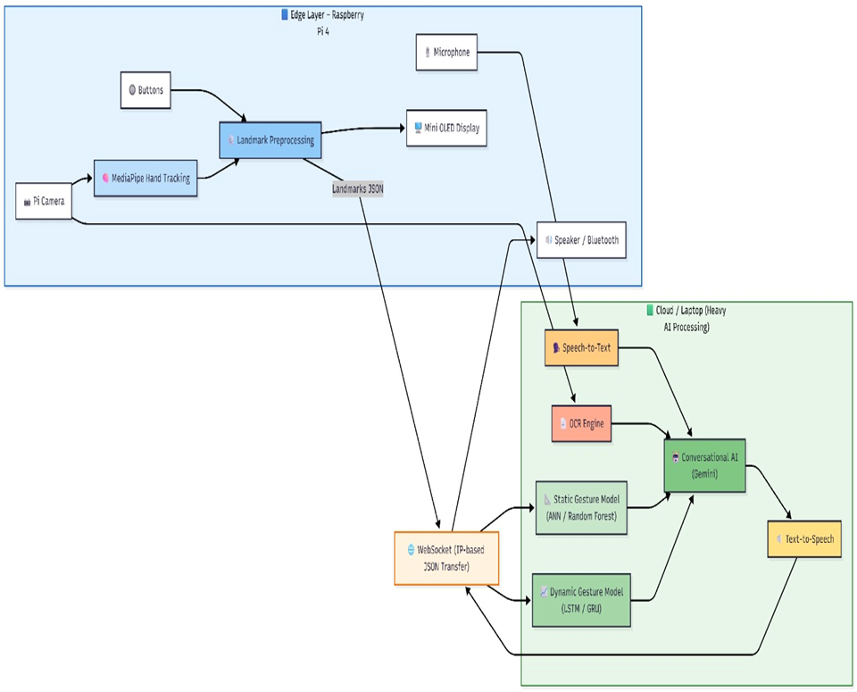
11  . | Current development status of the invention  - Has your invention been tested experimentally?  Prototype developed and experimentally validated with real-time deployment on Raspberry Pi 4 using Pi Camera and WebSocket communication.  - Describe the experimental approach of the invention also state the methods adopted in the experiment.  Yes. Multiple-user indoor tests were conducted under real-world conditions with static gesture datasets.  - Are the experimental data is documented in a formal log or any instrumental confirmation available for the invention (kindly provide the details)?  Experimental approach and methods:  - Data acquisition via Raspberry Pi camera  - MediaPipe extraction of 21 hand landmarks  - Landmark normalization and geometric feature engineering  - Random Forest classification  - AI sentence processing  - Text-to-speech output evaluation  Yes. Results include:  - Accuracy table (98%)  - Precision, recall, F1-score  - Confusion matrix  - Per-class accuracy plots  These are formally documented in the research manuscript.  - Is further development of your invention necessary or development of the invention is in progress (provide the relevant information)  Yes. Planned upgrades include:  - Dynamic gesture support  - Larger vocabulary  - Facial expression integration  - Multilingual support  - Full offline AI processing  - Mobile/wearable integration
12. | Please list any of your publications (including abstracts, posters, news releases, etc.) to emphasize the present invention background.
13. Kindly perform a prior art search (using Orbit Intelligence) at the DEI office, R. No. 608, 5th floor, BEL building, or using free unpaid databases (Google patents, ipindia, USPTO, Espacenet, Patentscope) and fill in the following details from the prior arts closest to your invention.
Patent No. and Title | Content disclosed in the document | Difference in your invention
CN114821783A – Real-Time Sign Language Gesture Recognition System Based on Deep Learning (Harbin University of Science and Technology, 2022) | This patent uses a standard camera with Google MediaPipe to extract 3D hand landmarks and applies deep learning (GoogLeNet + TripletLoss) for real-time sign language gesture recognition, mainly focused on gesture classification. | EdgeSign extends beyond gesture recognition by introducing:  - Edge–cloud hybrid Raspberry Pi deployment  - Landmark-only WebSocket transmission for privacy and low bandwidth  - AI-driven sentence generation for contextual communication  - Text + speech multimodal assistive output  - Portable battery-operable real-world assistive device
US10489639B2 – Automated Sign Language Translation and Communication Using Multiple Input and Output Modalities (2019) | This patent covers broad automated sign language translation using multiple sensors, neural networks, and multimodal communication involving sign, text, and speech translation. | EdgeSign specifically focuses on:  - Low-cost Raspberry Pi implementation  - Lightweight MediaPipe static gesture pipeline  - Embedded assistive deployment for affordability  - Structured landmark transmission instead of sensor-heavy architectures  - Practical educational and accessibility deployment rather than broad enterprise-scale systems
US20210174034A1 – Computer Vision Based Sign Language Interpreter | Uses computer vision for sign interpretation, phoneme generation, and sign-to-language conversion using visual fragments and advanced interpretation systems. | EdgeSign prioritizes:  - Cost-efficient edge computing  - Raspberry Pi hardware  - Low power consumption  - Simplicity and portability  - Faster deployment in developing accessibility markets

Publication title and author | Content disclosed in the document | Difference in your invention
George Sung et al., 2021 – On-device Real-time Hand Gesture Recognition | Google’s system uses MediaPipe Hands with on-device real-time static gesture recognition using RGB cameras and gesture classifiers. | EdgeSign adds sentence generation  Assistive communication focus  Raspberry Pi embedded deployment  Speech synthesis  Edge–cloud collaborative framework
Rupesh Kumar et al., 2023 – Mediapipe and CNNs for Real-Time ASL Gesture Recognition | ASL recognition using MediaPipe + CNN with high alphabet recognition accuracy, focused primarily on gesture detection. | Context-aware sentence construction  Practical portable hardware  IoT integration  User controls  Accessibility-first deployment
Sharvari Kamble, 2025 – SLRNet: Real-Time LSTM-Based Sign Language Recognition | Webcam-based real-time sign language system using LSTM for broader sign vocabulary. | Lower computational overhead using Random Forest  Raspberry Pi suitability  Reduced power consumption  Better deployment feasibility for low-cost embedded assistive products

Market available product/current technologies, if any | Features of the product | Difference in your invention
SignAll | AI-powered sign language translation kiosks using camera systems, enterprise-scale accessibility tools. | EdgeSign is lower cost  Portable personal device  Raspberry Pi-powered  Better accessibility for individual users rather than institutional infrastructure

14. INVENTOR(S) AND/OR CONTRIBUTOR(S):
 | INVENTOR (1) |  | INVENTOR (2)
Name and Gender: | Jeevan Baabu Murugan |  | Surya Sathyanarayanan
Address: | Department of _, College of _, SRM IST, Kattankulathur: 603 203 |  | Department of _, College of _, SRM IST, Kattankulathur: 603203
City and State: | Chennai & Tamilnadu |  | Chennai &Tamilnadu
Nationality | INDIAN |  | INDIAN
Email Id: (official and personal ID is required) | jm7531@srmist.edu.in jeevanbaabu03@gmail.com |  | ss7626@srmist.edu.in surya.sdp2004@gmail.com
Contact number: | 8438844636 |  | 8838335431

15. Mandate form to be filled for Technology Transfer Office (Mandatory)

- Market Demand for the problem solved using the invention:
There is a significant and growing global demand for affordable assistive communication technologies for individuals with speech and hearing impairments. Millions of people face daily communication barriers due to limited access to interpreters, expensive assistive devices, or inaccessible technologies. EdgeSign addresses this gap by offering a portable, low-cost, real-time communication solution suitable for healthcare, education, public services, and personal use. Increasing awareness around inclusive technology and accessibility regulations further strengthens market demand.

- Novelty of the solution compared to the existing market products:
EdgeSign differentiates itself through its unique combination of:
Raspberry Pi-based low-cost embedded deployment
Edge–cloud hybrid architecture
Landmark-only data transmission for privacy and reduced bandwidth
AI-driven sentence generation instead of isolated gesture translation
Real-time speech and text multimodal output
Unlike expensive enterprise systems or intrusive glove-based products, EdgeSign provides a practical, scalable, and privacy-conscious assistive communication ecosystem.

- Feasibility of the product:
The product is highly feasible due to the use of commercially available hardware (Raspberry Pi 4, Pi Camera Module), open-source frameworks (MediaPipe), and lightweight machine learning models (Random Forest). Experimental validation has already demonstrated 98% recognition accuracy with low latency, confirming technical feasibility. Manufacturing and deployment costs remain relatively low, making prototype-to-product transition realistic.

- Market-readiness of the product/TRL No.:
Estimated TRL Level: 6–7
(Technology demonstrated in relevant environment / System prototype demonstration)
The system has been prototyped, experimentally tested, and functionally validated in real-world indoor scenarios. Further work on dynamic gesture expansion, UI refinement, and commercialization strategy would move it toward TRL 8–9.

- Affordability or proposed price point in comparison to the existing market products:
Proposed price range: ₹8,000–₹18,000 depending on configuration
This is significantly lower than many existing assistive communication devices, which may cost ₹40,000–₹2,00,000+, especially glove-based or enterprise systems.
EdgeSign’s affordability makes it suitable for educational institutions, NGOs, clinics, and individual consumers in both developing and developed markets.

- Potential/Target Customers for the invention:
- Deaf and speech-impaired individuals
- Special education institutions
- Hospitals and rehabilitation centers
- Government accessibility programs
- NGOs working in disability inclusion
- Smart healthcare providers
- Public service communication centers
- Consumer accessibility tech markets
- Wearable assistive technology companies

- Potential Competitors for the provided solution:
- SignAll
- MotionSavvy (legacy gesture translation systems)
- Sensor glove-based sign language systems
- Google MediaPipe-based independent research systems
- AI-powered accessibility startups
- Smart wearable communication device manufacturers
Competitive advantage:
EdgeSign’s strongest position is affordability + portability + privacy + contextual AI communication, which many competitors lack simultaneously.

